Project Proposal

**Team Members**

* Megan Cochran, David Heritage, Jordan Gunter, & Akrum Mahmud

**Contact Person**

* Megan Cochran
* Email: mmc2n8@mail.missouri.edu

**Project Plan (meeting every week)**

* We will be dividing the work in small sprints to resemble agile development, and will meet at least weekly to both work together and see how each other’s work has been progressing.

**Project Description**

Project Title

* Knuckles the Echidna

Overview

* Our game will be similar in gameplay to the original Super Mario Bros. games, but with a similar visual appeal to Sonic the Hedgehog. We want to feature Knuckles the Echidna, one of the supporting characters in Sonic, as our playable character to give him a chance to be the main character. The user’s goal is to collect as many coins as possible while also correctly navigating through the levels.

Methods

* Spawn Coins:

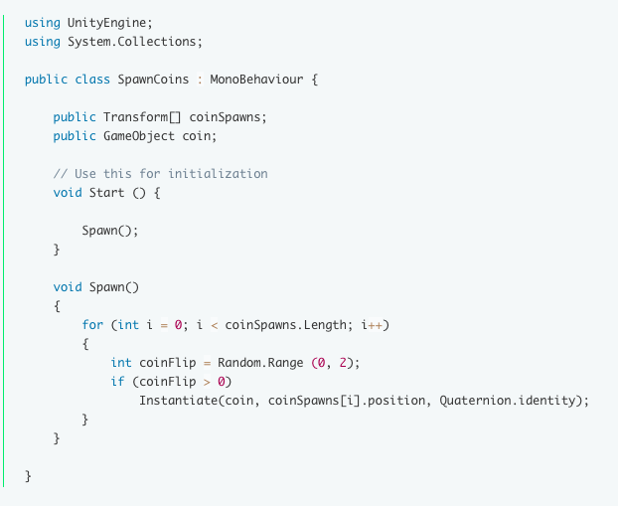

* Pick-Up Coins:
  + 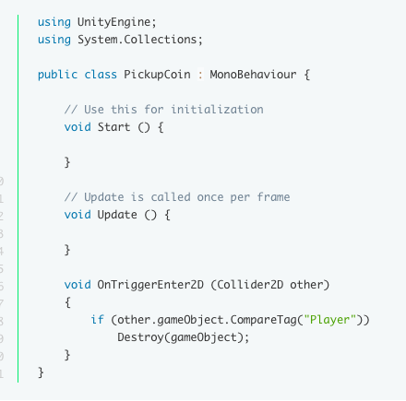

**Project Management Plan**

* We will use the website Trello to keep track of development tasks that will be sorted by category. This will help us mimic a more agile development environment by assigning tasks, working in small sprints, moving tasks through the development cycle, and keeping an eye on how each member’s work load is going.
* Regular Meetings: We will meet weekly after our Thursday class.
* Role Assignments: David will work on level design, while Megan will focus on character functionality.